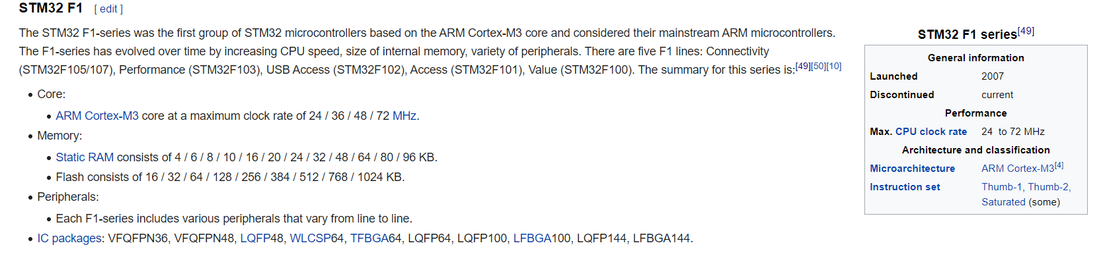

The board is equipped with an [STM32F103C8T6](http://www.st.com/content/st_com/en/products/microcontrollers/stm32-32-bit-arm-cortex-mcus/stm32f1-series/stm32f103/stm32f103c8.html) microcontroller compatible with the [NUCLEO-F103RB](https://developer.mbed.org/platforms/ST-Nucleo-F103RB/) platform.

Microcontroller features

* STM32F103C8T6 in LQFP48 package
* ARM®32-bit Cortex®-M3 CPU
* 72 MHz max CPU frequency
* VDD from 2.0 V to 3.6 V
* 64 KB Flash
* 20 KB SRAM
* GPIO (32) with external interrupt capability
* 12-bit ADC (2) with 10 channels
* RTC
* Timers (4)
* I2C (2)
* USART (3)
* SPI (2)
* USB 2.0 full-speed
* CAN

Board features

* Small foot-print
* Flexible board power supply: USB VBUS or external source (3.3V, 5V)
* User LED: LED1
* One push button: RESET
* Programming/Debug port
* Micro-B USB connector

## Board pinout

## Maximum allowed I/O voltage levels (next to pin names) are courtesy of [Thor Sten](https://developer.mbed.org/users/Thorsten/) to help you avoid board damage. For more details on pin definitions see Table 5 in the [Datasheet](http://www.st.com/content/ccc/resource/technical/document/datasheet/33/d4/6f/1d/df/0b/4c/6d/CD00161566.pdf/files/CD00161566.pdf/jcr:content/translations/en.CD00161566.pdf).

Also notice that the on-board LED is connected to pin PC_13 and, via a resistor, to +3.3V. So to turn the LED on or off you have to set the DigitalOut to 0 or 1 respectively.

